SharpDevelop Commands API

Introduction
This article will explain process of making shortcuts defined in your add-in customizable by user. You will learn general idea behind commands API and how to use in most common scenarios.
But first let’s look at some arguments why you should use Commands API in the first place; if making users happy by allowing them to use whatever shortcuts they like you can go ahead and skip this section all together. If not here goes:
Conflicts discovery. First thing that comes to mind is developers breaking each other shortcuts by assigning other actions to same key combinations. Can you guaranty that “Ctrl+I” gesture you came up for “extract interface” command won’t be used by other developer to “insert a snippet”? As you may guess checking for conflicting gestures is a not an easy task alone, but doing it keeping it very difficult if possible at all. When you use Commands API all your shortcuts appear in shortcuts options panel making it trivial to search and solve conflicts.
Adaptability. Another thing you should be aware of is your fellow developers migrating to SharpDevelop. Somebody with Visual Studio or Eclipse background may want to continue using same shortcuts he was using for years in another IDE. Not allowing users to use familiar gestures may turn them away from SharpDevelop. Wouldn’t you suffer if forced to use editor where “Ctrl+Insert” is preferred over “Ctrl+V”? It’s not impossible to learn but why should you bother when that is not what you came for? If you’ll use Commands API users will be able create or use predefined shortcut profiles leaving them just few clicks away from using their favorite shortcuts.
Shortcuts discovery. Finally, have you ever wondered what shortcuts are available in application or what that key combination you just accidently pressed does? Shortcuts option panel allows users to search through all registered shortcuts by title or key combination.
I hope these three arguments are enough to motivate you reading further through this tutorial especially because using Commands API is not hard at all.

API
As mentioned before Commands API is pretty easy to use; in fact if you used routed commands in WPF most of concepts will look very familiar. Here is how SharpDevelop’s shortcut API looks like compared to WPF.

WPF vs SD
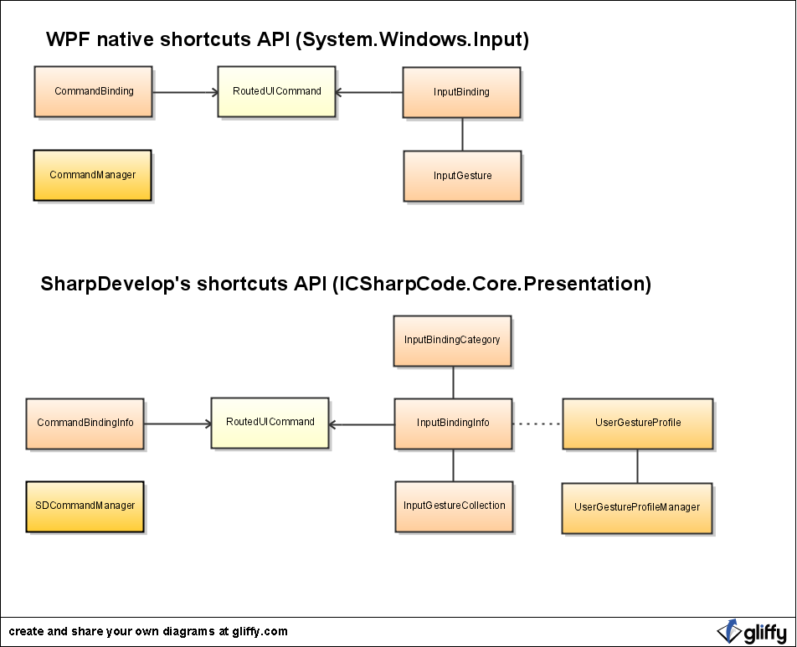
As you can see it looks similar to API provided by WPF allowing people already familiar with it to learn faster. However there are some differences too. For those who haven’t used routed commands before I strongly suggest reading a little about them first.
First is SDCommandManager class. Much like native CommandManager class this is utility class used to register bindings, named instances, input binding categories and all other things related from Commands API.
Then there are CommandBindingInfo and InputBindingInfo classes which describe CommandBinding and InputBinding objects and reference to an owner. Most notable difference between these is that binding infos uses named instances to reference owner while bindings are attached directly to owner. There is a reason for that additional complexity of course. Because binding infos are stored in *.addin file between application sessions every binding owner must have a permanent name. There are two types of named instances provided: named UIElement and named UIType. Moreover, each name can have several instances assigned to it and each instance can be assigned with several different names.
Next is InputBindingCategory. This class exists for a single purpose, to group input bindings and then present them to user as tree of items and categories. You will see categories in action in the demo application which will follow shortly.
Finaly, UserGestureProfile and UserGestureProfileManager classes are used to replaces predefined gestures with ones set by user. When developing your application you will be using InputBindingInfo.ActiveGestures and UserGestureProfileManager will decide what these are for you.

API demo add-in
But enough talking; let’s build a simple demo add-in. We’ll try to keep it as simple as possible to concentrate on commands. Our add-in will perform two actions: counting words and counting lines in opened document. For that we will need two implementations of ICommand class:
LineCountCommand.cs
using System;
using System.Text.RegularExpressions;
using System.Windows;
using ICSharpCode.Core;
using ICSharpCode.SharpDevelop.Gui;
using ICSharpCode.SharpDevelop.Editor;
namespace ShortcutsAPIDemo
{
public class LineCountCommand : AbstractMenuCommand
{
public override void Run()
{
var provider = WorkbenchSingleton.Workbench.ActiveContent as ITextEditorProvider;
if (provider == null) {
MessageBox.Show("Not a text editor control");
return;
}
// Get all text in current text editor
var reader = provider.TextEditor.Document.CreateReader();
var text = reader.ReadToEnd();
// Count lines in the text
var linesCount = Regex.Matches(text, @"\n", RegexOptions.Multiline).Count + 1;
// Display to user
MessageBox.Show(string.Format("Line count: {0}", linesCount));
}
}
}

WordCountCommand.cs
using System;
using System.Text.RegularExpressions;
using System.Windows;
using ICSharpCode.Core;
using ICSharpCode.SharpDevelop.Gui;
using ICSharpCode.SharpDevelop.Editor;
namespace ShortcutsAPIDemo
{
public class WordCountCommand : AbstractCommand
{
public override void Run()
{
var provider = WorkbenchSingleton.Workbench.ActiveContent as ITextEditorProvider;
if (provider == null) {
MessageBox.Show("Not a text editor control");
return;
}
// Get all text in current text editor
var reader = provider.TextEditor.Document.CreateReader();
var text = reader.ReadToEnd();
// Count words in the text
var wordsCount = Regex.Matches(text, "[^ ^t^n]+").Count + 1;
// Display to user
MessageBox.Show(string.Format("Word count: {0}", wordsCount));
}
}
}

Shortcuts in main menu
Now we can go ahead and add menu item which would invoke “LineCountCommand”. This is done exactly same way it was always done in SharpDevelop.
<Path name = "/Workspace/Tools">
<MenuItem id = "CountLines"
label = "Count lines"
class = "ShortcutsAPIDemo.LineCountCommand"/>
</Path>
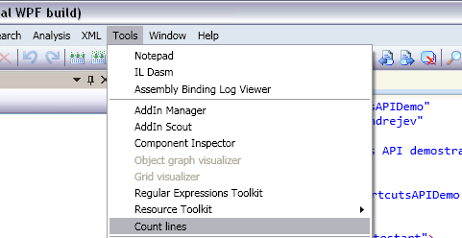
However there is something new happening under the hood. SharpDevelop automatically registered input and command bindings infos needed to create all commands and shortcuts in main menu. That means if you will go to "Tools->Options->Text Editor->Shortcuts management and search for “Count Lines” you will see that there is a new entry there. Go ahead and modify gesture assigned to this input binding info.
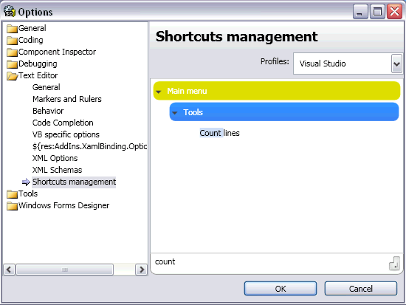
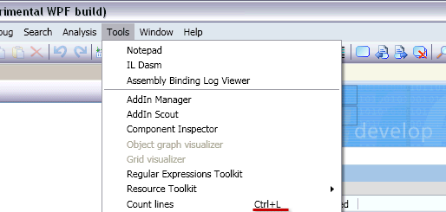
As you can you didn’t even had to do anything except adding a menu item and you already using Commands API. Only thing you might find missing here is default gesture. Use “shortcut” attribute in MenuItem node to specify it.

Shortcuts not in main menu
But what if you don’t want to place your command into main menu? Like in WPF you will have to register InputBindingInfo and CommandBindingInfo in SDCommandManager. You would also need to register RoutedUICommand if you want to specify user readable text describing routed command.
ShortcutsAPIDemo.addin
<Path name="/SharpDevelop/CommandManager/RoutedUICommands">
<RoutedUICommand name="ShortcutsAPIDemo.CountWords" text="Count words" />
</Path>
<Path name="/SharpDevelop/CommandManager/CommandBindings">
<CommandBindingInfo command="ShortcutsAPIDemo.CountWords"
class="ShortcutsAPIDemo.LineCountCommand" lazy="true" />
</Path>
<Path name="/SharpDevelop/CommandManager/InputBindings">
<InputBindingInfo command="ShortcutsAPIDemo.CountWords" gestures="Ctrl+W" />
</Path>
Go back to “Shortcuts management” panel and see whether new input binding info appeared.
.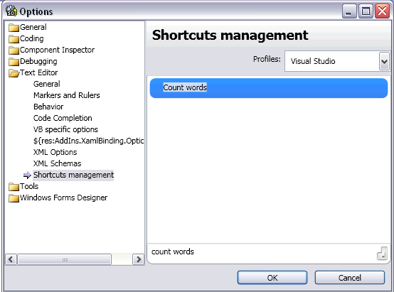
As you can see it is there but it is not under any category. You can fix that by creating relationship between InputBindingInfo and InputBindingCategory. Just add categories attribute to InputBindingInfo node. You can list multiple categories separated by comma too. Every menu item from main menu creates a category with the same path as menu item itself. You can use these to begin from and if that is not enough you can register your own by placing InputBindingCategory node in “/SharpDevelop/CommandManager/InputBindingCategories” path.
ShortcutsAPIDemo.addin
<Path name="/SharpDevelop/CommandManager/InputBindings">
<InputBindingInfo command="ShortcutsAPIDemo.CountWords" categories="/MainMenu/Tools" />
</Path>

Shorter syntax for registering bindings in *.addin file
If you think that registering bindings and routed command is an overhead for your scenario you can put all the attributes inside CommandBindingInfo node. Just don’t forget setting gestures attribute (atleast to empty string); otherwise SharpDevelop won’t know that you want to create InputBindingInfo too.
ShortcutsAPIDemo.addin
<Path name="/SharpDevelop/CommandManager/CommandBindings">
<CommandBindingInfo command="ShortcutsAPIDemo.CountLines"
commandtext="Count lines"
class="ShortcutsAPIDemo.LineCountCommand"
categories="/MainMenu/Tools"
gestures="Ctrl+L" />
</Path>

Shortcut scope
Finally, as you may have noticed there was no shortcut scope specified. Omitting the scope means bindings will apply to global scope. To specify different InputBindingInfo or CommandBindingInfo owner use “ownerinstnace” or “ownertype” attributes. For example you may want to count words only in AvalonEditViewContent. To set the owner, add “ownerinstance” attribute with “ICSharpCode.AvalonEdit.AddIn.AvalonEditViewContent, ICSharpCode.AvalonEdit.AddIn” value to CommandBindingInfo node.
ShortcutsAPIDemo.addin
<Path name = "/Workspace/Tools">
<MenuItem id = "CountWords"
label = "Count words"
command = "ShortcutsAPIDemo.CountWords"/>
</Path>
<Path name="/SharpDevelop/CommandManager/CommandBindings">
<CommandBindingInfo command="ShortcutsAPIDemo.CountWords"
commandtext="Count words"
class="ShortcutsAPIDemo.WordCountCommand"
categories="/MainMenu/Tools"
gestures="Ctrl+W"
ownerinstance="ICSharpCode.AvalonEdit.AddIn.AvalonEditViewContent, ICSharpCode.AvalonEdit.AddIn"
lazy="true" />
</Path>
Also you could have added “ownertype” attribute to apply bindings to the whole type instead.
Be aware that names are associated with instances by hand in code and if you want to use different scope you must associate an instance with a name using SDCommandManager.RegisterNamedUIElement or SDCommandManager.RegisterNamedUIType. But there are some predefined associations for your comfort. All opened document container instances get a name associated with that instance automatically and all pad container types get theirs too. To search for available scopes SDCommandManager.RegisteredNamedUIElements or SDCommandManager.RegisteredNamedUITypes properties can be used.

Binding groups
Finally, you may come across a situation where you would prefer a group of bindings being enabled and disabled depending on situation at hand. In that case you will need to associate BindingGroup with to CommandBindingInfo or InputBindingInfo. If binding info has at least one BindingGroup associated with it every potential binding owner is checked within BindingGroup to see whether it belongs to any of them. Let’s make a small demonstration of this feature.
First we need two new commands. One will assign a group to binding info; another will register UIElement instance in group so that command binding would become available.
AutoStartCommand.cs
using System;
using System.Collections.Specialized;
using System.Linq;
using ICSharpCode.Core;
using ICSharpCode.Core.Presentation;
namespace ShortcutsAPIDemo
{
public class AutoStartCommand : AbstractCommand
{
public static BindingGroup WordCountGroup = new BindingGroup("Word count group");
public override void Run()
{
var shortcutsAPIDemoAddIn = AddInTree.AddIns.First(a => a.Name == "ShortcutsAPIDemo");
// Register input binding info
var inputBindingInfo = new InputBindingInfo();
inputBindingInfo.OwnerInstanceName = "ICSharpCode.AvalonEdit.AddIn.AvalonEditViewContent, ICSharpCode.AvalonEdit.AddIn";
inputBindingInfo.RoutedCommandName = "ShortcutsAPIDemo.CountWords";
inputBindingInfo.Groups.Add(WordCountGroup);
inputBindingInfo.AddIn = shortcutsAPIDemoAddIn;
SDCommandManager.RegisterInputBindingInfo(inputBindingInfo);
// Register command binding info
var commandBindingInfo = new CommandBindingInfo();
commandBindingInfo.OwnerInstanceName = "ICSharpCode.AvalonEdit.AddIn.AvalonEditViewContent, ICSharpCode.AvalonEdit.AddIn";
commandBindingInfo.RoutedCommandName = "ShortcutsAPIDemo.CountWords";
commandBindingInfo.CommandTypeName = "ShortcutsAPIDemo.WordCountCommand";
commandBindingInfo.AddIn = shortcutsAPIDemoAddIn;
commandBindingInfo.Groups.Add(WordCountGroup);
SDCommandManager.RegisterCommandBindingInfo(commandBindingInfo);
}
}
}

EnableWordCountCommand.cs
using System;
using System.Windows;
using System.Windows.Controls;
using ICSharpCode.Core;
using ICSharpCode.SharpDevelop.Gui;
using ICSharpCode.SharpDevelop.Editor;
using AvalonDock;
namespace ShortcutsAPIDemo
{
public class EnableWordCountCommand : AbstractCommand
{
public override void Run()
{
var contentControl = WorkbenchSingleton.Workbench.ActiveViewContent.WorkbenchWindow as ContentControl;
if(contentControl == null) {
return;
}
var uiElement = contentControl.Content as UIElement;
if(uiElement == null) {
return;
}
// Register owner in binding group
AutoStartCommand.WordCountGroup.RegisterHandledInstance(uiElement);
}
}
}
AutoStartCommand will be invoked when SharpDevelop starts and EnableWordCountCommand will be callable from main menu. That means we have to add two new elements to add-in tree.
<Path name = "/Workspace/Autostart">
<Class id = "RegisterWordCountGroup" class = "ShortcutsAPIDemo.AutoStartCommand">
</Path>
<Path name = "/Workspace/Tools">
<MenuItem id = "EnableCountWords"
label = "Enable count words"
class = "ShortcutsAPIDemo.EnableWordCountCommand"/>
</Path>
Try these two new items. Counting words is disabled until “ShortcutsAPIDemo.EnableWordCountCommand” command is executed.

